CLASS COPY
Lab Activity: GeoPatterns (from “Project Earth Science: Geology”)
Objective: Study earthquake distribution around the world and look for patterns of earthquake distribution.
Materials:

- All five panels of the strip map
- Scissors
- Glue (or clear tape)
- Atlas or globe with map of ocean floors
- Colored pencil

Procedure:
- Your teacher will give you five strip map panels (BLMs 1–5). Cut the panels out along their outside edges.
- 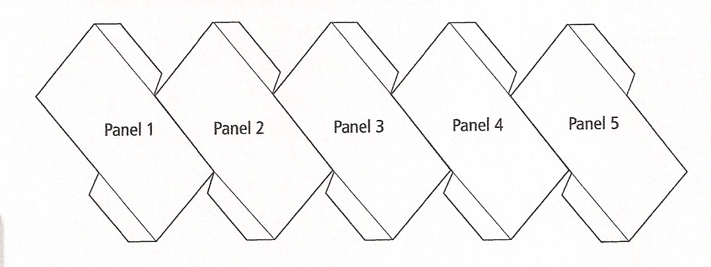Lay the panels face up on your table, aligning them as shown in Figure 1.1. Glue (or tape) the panels together along the tab lines, but at this point do not connect panel 5 to panel 1. Now you have a map of the world that also can be assembled into a type of globe.

- Your map shows thousands of dots. Each dot marks the location on the surface directly above where an earthquake originated (its epicenter).
- Your teacher may suggest that you color certain regions of the map. It is easiest to color your panels at this point, before you transform them into a globe.
- Fold each of the panels along the straight lines printed on the map and along the tab lines. (This will make forming the globe shape easier.)
- Join panels 5 and 1 by gluing or taping together their tabs. Finish your globe by folding panels inward along the creases and gluing or taping connecting panels together.
- Once you are finished, examine your globe closely. Locate the various continents and ocean basins. Also notice the thousands of dots, each representing the epicenter of an earthquake. Look closely at the distribution of these dots over Earth’s surface.
Questions: Answer the following questions in your science notebook, please use complete sentences.
- What do you observe about the location of earthquake epicenters on your globe? Are these distributed randomly or in patterns around the world?
- Do certain features appear in a pattern, or does randomness seem to be the rule on the seafloor? Give an example to support your answer.
- Compare the distribution of earthquakes on your globe and the distribution of features on the seafloor. Do you think there is a connection between these different phenomena? Why or why not?
- What else would you like to know about earthquakes?

